**Job Cost Calculation**

As you can see below, Job 203537 is for 110,000 boxes. The cost per thousand (Cost/M) for material is shown as $ 71.8137, Direct Labor is $56.3994, Fixed Overhead is $14.1974 and Variable Overhead is $8.1446. The cost/M for all materials are added together to total the cost/M of the finished good item’s job cost. Each materials Cost/M = MRP x Cost per UOM / Job Quantity x 1000. One exception is Board material, which is pulled from the Routing Sheets from 1st machine.

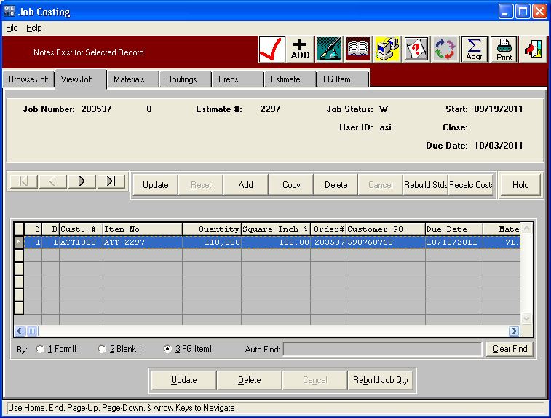

**Material Cost Calculation**

Job 203537 is for 110,000 boxes. The Varnish cost is $10 per pound shown as LB. The Materials Required Planned (MRP) shows 82.851616 pounds needed to make 110,000 boxes. Therefore the cost for VARN is $ 828.52 /110,000 x 1000 = $7.5320/M. Each material cost is calculated with the same formula as Cost/M = MRP x Cost per UOM / Job Quantity x 1000. However, Board is a little different depending on the unit of measure (UOM) that the inventory is consumed. In this example, board is stocked by the Lineal foot (LF). The MRP is not used in the calculation. The MRP is calculated depending on the N-K-1 Job Qty character value and logical value so that the quantity of sheets on the job ticket and job file may be different. Most often the MRP and Sheets fed into the 1st machine from the Routing Folder are identical. In this example, they are not. The routing folder shows 30,785 including overrun and waste whereas the MRP is showing net sheets as 100,000 / 4 UP = 27,500 sheets. The sheet length of 34.25 / 12 = 2.85417 feet per sheet x 30,785 x $ .0631 LF = $5,539.52 / 110,000 boxes x 1000 = $ 50.359/M boxes which is rounded to $50.3640. If you add all the cost/M on the materials folder, this will equal $71.8137 that is shows on the View Job folder, the Job cost in the Finished Goods file and the order entry cost in the order.

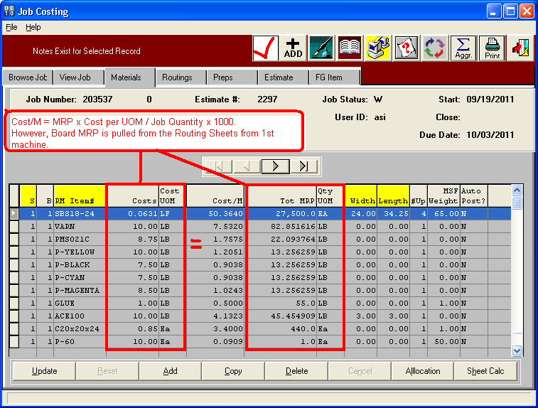

**ROUTING Folder Calculation**

Job 203537 is for 110,000 boxes. Sheets needed for the Job are always listed on the Machine Routing folder. This shows the sheets that are feed into the first machine for the job. This is used for the Cost/M calculation for board material. Please note, the cost for directly labor, fixed overhead and variable overhead simply multiple the total make ready (MR) hours plus Run runs on the Routing folder times the machine rates from the machine file.

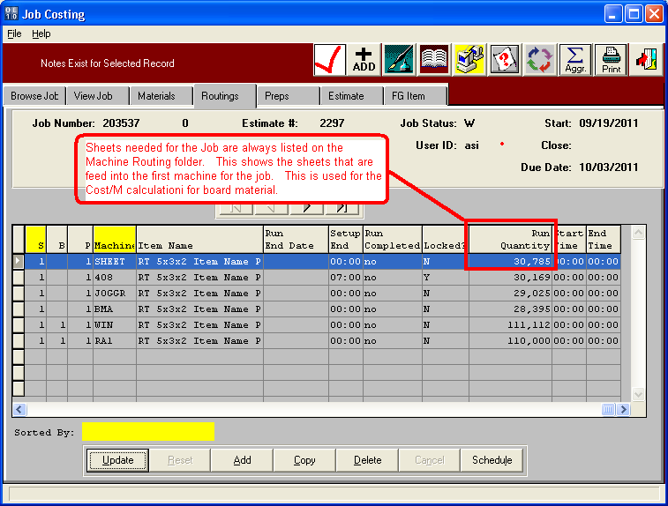

**Machine File – Machine Rates**

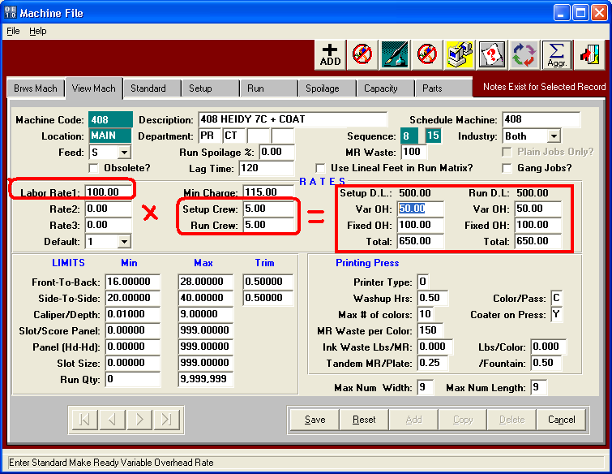

**Job File – Routing Folder**

